## Reports Menu/ Pharmacist Report/User Name and ID:

Request:

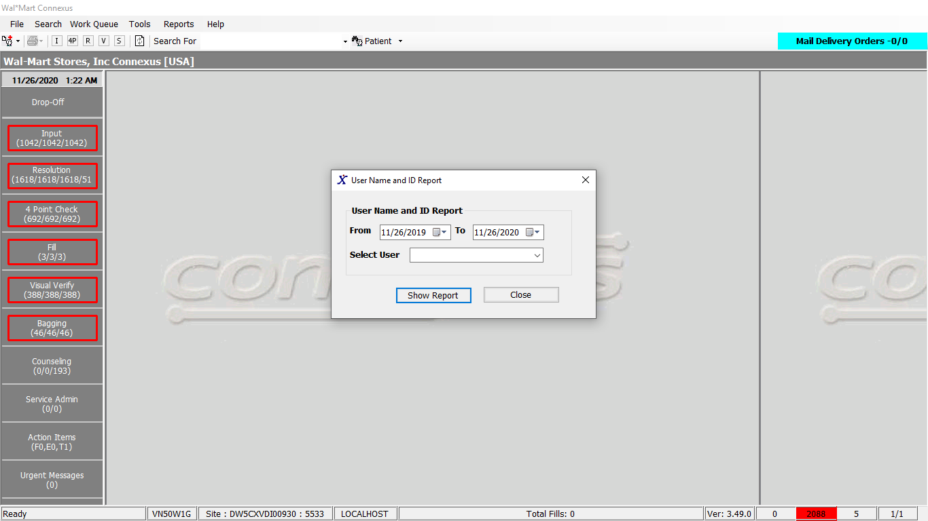

Response:

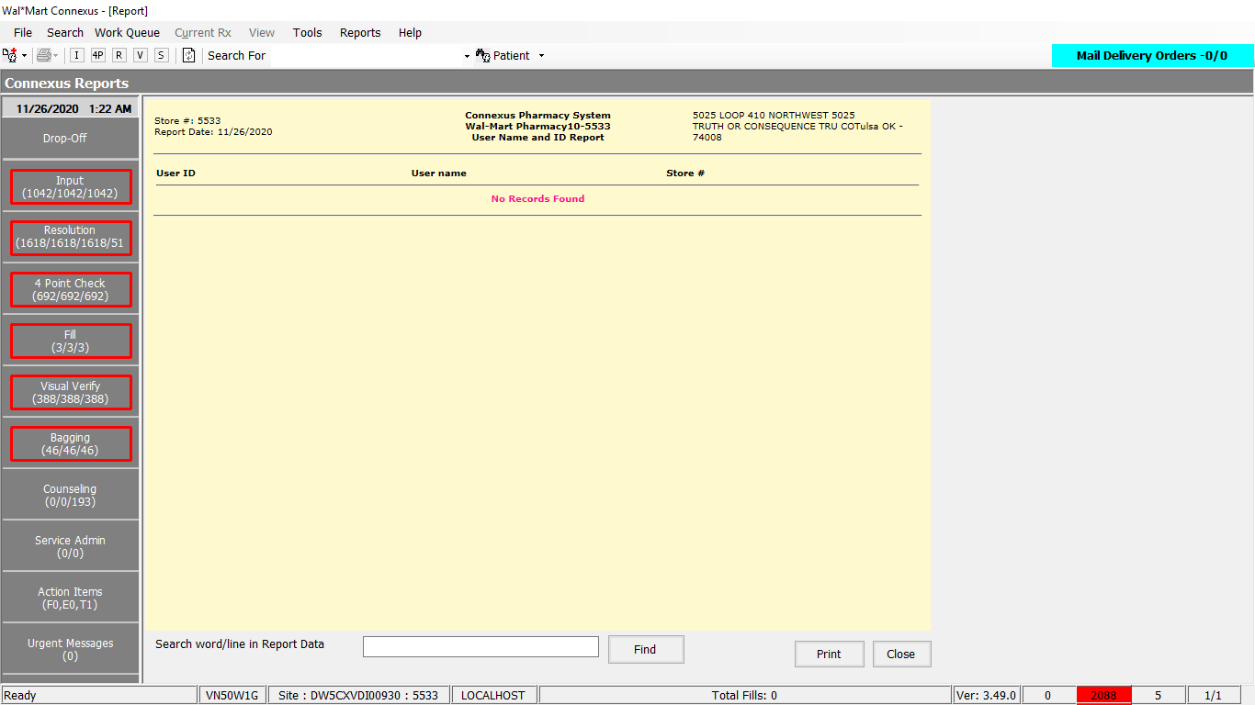

Queries:

Friend Const GetPermanentRecordData As String = " SELECT su.userid, su.user_descr, NVL(su.store_nbr, pb.phm_bu_id) store_nbr " &

" FROM phm_appl_security:system_user su, rx21c:pharmacy_bu pb " &

" WHERE su.userid IN (SELECT aa.userid " &

" FROM error_and_audit:appl_activity aa " &

" WHERE aa.activity_type_code = 1025 " &

" AND DATE(aa.activity_ts) BETWEEN ? AND ? ) "

DAL:

Public Function GetPermanentRecordData(ByVal siteId As Integer, ByVal beginDate As Date, ByVal endDate As Date, ByVal userID As String) As List(Of GetPermanentRecordInfoBE) Implements IReportDAL.GetPermanentRecordData

Using (New Tracer(ConnexusCommonConstants.ConnexusTracer))

Dim getPermanentRecordInfoBEList As New List(Of GetPermanentRecordInfoBE)

Dim response As New GetPermanentRecordInfoBE

Dim sqlString As New StringBuilder()

Dim paramList As New List(Of DbParameter)

sqlString.Append(ReportQueries.GetPermanentRecordData)

paramList.AddParameter(DbType.Date, beginDate, "startDate")

paramList.AddParameter(DbType.Date, endDate, "endDate")

'Check if the input user id is empty and append it to the sql query

If Not String.IsNullOrWhiteSpace(userID) Then

sqlString.Append(" AND su.userid = ? ")

paramList.AddParameter(DbType.String, userID.ToUpper.Trim, "userID")

End If

sqlString.Append(" ORDER BY UPPER(su.userid) ")

Dim dr As IDataReader = ExecuteReader(DatabaseEnum.Phm_Appl_Security, siteId, sqlString.ToString, paramList)

While dr.Read()

response = New GetPermanentRecordInfoBE

response.UserId = dr.GetValueOrDefault(Of String)("userid")

response.UserDesc = dr.GetValueOrDefault(Of String)("user_descr")

response.UserStoreNumber = dr.GetValueOrDefault(Of Int32)("store_nbr")

getPermanentRecordInfoBEList.Add(response)

End While

Return getPermanentRecordInfoBEList

End Using

End Function